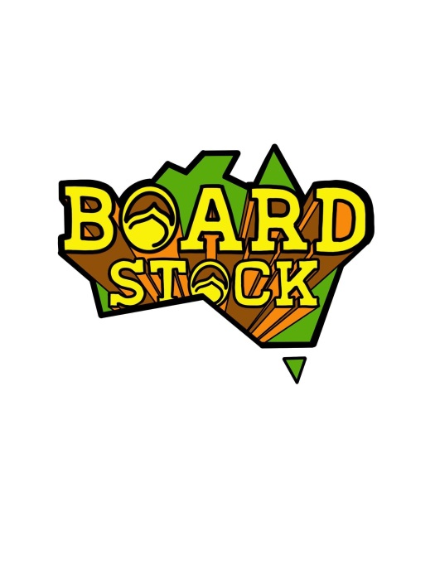

March 28 and 29 . BLI BLI Wake Park

2020 BOARDSTOCK Registration Form
Athlete Name: |  |  |  |  |  |  |  |  |  | Male/Female
Address:
City: |  |  |  | State: |  |  |  |  | Postal Code:
Phone: |  |  |  |  | Fax:
Email: |  |  |  |  |  | Age: |  |  | Date of Birth:

Divisions: Please mark with an “X” next to your event and division you wish to enter
(Please note some divisions may be combined with others when there is less than 3 entries)
BI LEVEL Challenge – Pro Riders ONLY …$50 entry
.…….ProWomen.…….Pro Men
KING OF KICKER….$30 entry
.…….UNDER 13 BOYS - 13 years at July 1 2019.…….UNDER 17 GIRLS - 17 years at July 1 2019
.…….UNDER 17 BOYS - 17 years at July 1 2019.…….Amateur Men……..Amateur Women
……….Pro Women.…….Pro Men
LIQUID FORCE Rail Jam….$50 entry
.…….KIDS CLUB BOYS.…….KIDS CLUB GIRLS
.…….UNDER 13 BOYS - 13 years at July 1 2019.…….UNDER 13 GIRLS - 13 years at July 1 2019
.…….UNDER 17 BOYS - 17 years at July 1 2019.…….UNDER 17 GIRLS - 17 years at July 1 2019
Wakeskate………Amateur Women.…….Amateur Men.…….Pro Women.…….Pro Men
Traditional Cable Contest….$50 entry
.…….OPEN Division All ages, Men and Women and Juniors
(A minimum of 3 entries will be necessary to stage any division in any of these events)

In entering any of these events the rider agrees to ensure that their conduct does not bring discredit to the venue, its management and/or the sponsors or organizers of the event, on or off the competition site before, during or after any of these events. Behaviour that may cause action to be taken, including disqualification from any current or future events, may include but not be limited to violence, theft, vandalism, outspoken or offensive opinions, swearing, equipment abuse, substance or alcohol abuse, under-age drinking, unsportsmanlike conduct, or any actions deemed to bring the event or the sport into disrepute. Furthermore the rider acknowledges that the management of these events and any associated series will uphold, respect and honour any restrictions or limitations placed upon any riders by any other governing body or association within the wakeboard industry. ML Watersports as the governing body of the Boardstock event reserves the right to refuse entry to any rider at its sole discretion.

ENTRY DEADLINE – Will be 5pm Monday March 23rd LATE FEES – A late fee of $20 per event WILL be charged for ANY entries received after the deadline, if there is space still available

TOTAL ENTRY ENCLOSED………………………………
All Registration Forms should be sent by email or fax to
BLI BLI WAKE PARK Email: info@blibliwatersports.com.au Phone: 07 5448 7555

Payment Type (Please Mark with “X” or Highlight)

VISA MasterCard
Card #______________________________________________ Exp _______

Name on Credit Card _________________________________________________________
Billing Address for Credit Card _____________________________________________________ _

